**KAYUNGA DISTRICT FOOTBALL ASSOCIATION (KDFA)**

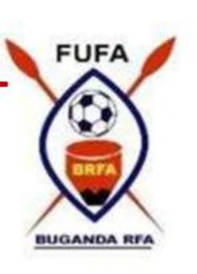

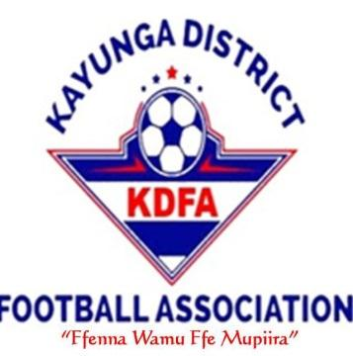

**P.O BOX 18000, KAYUNGA**















































































[**Tel: 0772-064**](Tel:0772-064) **333 / 0701-064 333 / 0759670062**



**5TH DIVISION LEAGUE 2023/2024 TABLE STANDING AS ON 12TH /6/ 2024**



********

|  |  |  |  |  |  |  |  |  |  |
| --- | --- | --- | --- | --- | --- | --- | --- | --- | --- |
| **NO** | **TEAM** | **P** | **W** | **D** | **L** | **F** | **A** | **GD** | **PTS** |
| **01** | **RISING SUNSHINE** | **4** | **4** | **0** | **0** | **8** | **0** | **8** | **12** |
| **02** | **THE VENOMS** | **4** | **3** | **1** | **0** | **3** | **0** | **3** | **10** |
| **03** | **HOPEFUL FUTURE** | **4** | **3** | **0** | **1** | **7** | **5** | **2** | **9** |
| **04** | **BBAALE FC** | **4** | **2** | **1** | **1** | **3** | **2** | **1** | **7** |
| **05** | **KASOKWE FC** | **4** | **1** | **1** | **1** | **1** | **1** | **0** | **4** |
| **06** | **RANGERS FC** | **4** | **0** | **1** | **3** | **1** | **4** | **-3** | 1 |
| **07** | **KISAWO FC** | **4** | **0** | **1** | **3** | **1** | **7** | **-6** | **1** |
| **08** | **NAKYESSA SS** | **4** | **0** | **0** | **4** | **0** | **5** | **-5** | **00** |

**NB: PROMOTED TO 4TH DIVISION RETAIN TO 5TH DIVISION**

**REL**





***KIRWANA MUZAMIRU***









***“****FENNA WAMU FFE MUPIIRA****”***